Name of the Member: John Angelo Sinfuego
Report Date: 10/21/24

For each task you are currently working on or plan to work on in the next period:
- Task number/name
General Task 8 10-21-24- Optimize the running of yolo

Personal Week 8 10-21-24- - 2. Send commands to robot via powershell

b. We are still research methods to optimize the running of yolo through the uni-go1 camera. I however, sent commands to the robot via powershell uning Unitree_legged_sdk. When the certain commands were sent, the robot would move accordingly to the given code.

Name of the Member: John Angelo Sinfuego
Report Date: 10/14/24

For each task you are currently working on or plan to work on in the next period:
- Task number/name
General Task 6 10-7-24- Incorporate yolo on dog

Personal Week 8 10-7-24- - 2. Research more and possibly start sending command ot dog
a. For our general tasks, my group members and I successfully ran YOLO on uni-go1. We can now transition into our next steps. I also research more on unitree_legged_sdk and will be incorporating that soon as well.

b. N/A solution to make the speed and run time faster.
- Outcome of the task activity

Name of the Member: John Angelo Sinfuego
Report Date: 9/30/24

For each task you are currently working on or plan to work on in the next period:
- Research more on legged_sdk
General Task 5 10-4-24- N/A

Personal Week 5 10-4-24- - Send commands to robot via powershell, create code to monitor performance
2. Short description
a. I researched some more ways to send commands to the robot via powershell. I found this repository of legged sdk and researched more into it.

b. github repo: unitreerobotics/unitree_legged_sdk: SDK tools for control robots. (github.com)

Name of the Member: John Angelo Sinfuego
Report Date: 9/30/24

For each task you are currently working on or plan to work on in the next period:
- Task number/name
General Task 5 9-30-24- Incorporate our model onto unitree, Run tests in order to access camera

Personal Week 5 9-30-24- - Kill nano1 camera process on dog in python, create a fuction so start new live feed oc camera
2. Short description
a. We made significant progress in this project. My team members and I managed to get the YOLOv8 repository running through the camera in uni-go1. This means we can get live feed with live object detection from Uni-Go1. We can then advance onto our next step involving Uni-Go1 and interacting with the object detection through YOLOv8.

b. For our challenges, the camera when run by YOLOv8 is running relatively slow and we are currently looking for a solution to make the speed and run time faster.
- Outcome of the task activity

Name of the Member: John Angelo Sinfuego
Report Date: 9/16/24

For each task you are currently working on or plan to work on in the next period:
- Task number/name
General Task 5 9-16-24- Incorporate our model onto unitree, Run tests in order to access camera

Personal Week 5 9-16-24- - Search for methods to run YOLOv8 directly from go1, Look into UniTree ROS(Video/Movement), Gather Software/code resources for potential use.
2. Short description
a. We must incorporate our YOLOv8 model into unitree so we can access the yolo repository into our robot’s live footage as well as run tests so we can access our camera. This is found within the files in unigo1. We have found a repository which could be useful for retrieving video and movement from unigo1. The UniTree ROS for the unigo1 robot which utilizes video/movement. We are going to be using UniTree ROS1 since ROS2 is not compatible with unigo1. This repository utilizes simulation packages for unitree robots and could be very useful in the future.

b. For our challenges, we still have trouble incorporating our YOLOv8 repository into unigo1. Since our dog does not have wi-fi, we still have to find a solution for this and are still researching it. We figured out that

- Outcome of the task activity

Repository for unitree ROS1
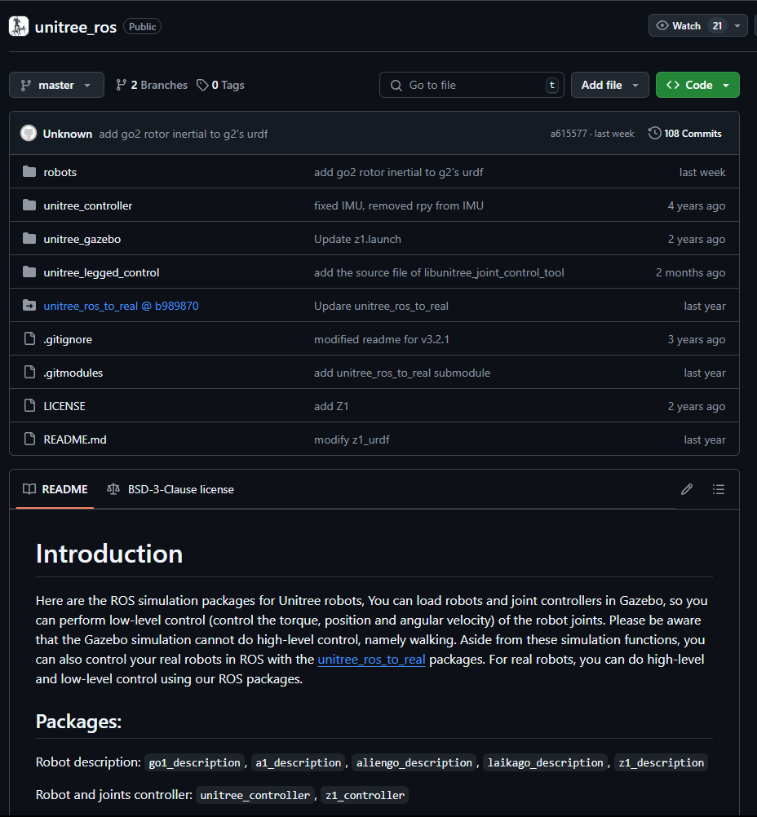

For each task you are currently working on or plan to work on in the next period:
- Task number/name
General Task 5 9-23-24- Run tests to access camera

Personal Week 5 9-23-24- - Kill nano1 camera process on dog in python, create a function to start new live feed on camera, Gather software/code resources for potential use
2. Short description
a. We have to kill the nano1 camera process on the dog and we will do this using python. We have to kill this process because it is required to run the YOLOv8 repository on unigo1 so we can retrieve object detection through the dog. I will also be looking into creating a function to start new live feed within the camera. I have looked into the untree_ros repository and there are some code that can be useful. Specifically code that we can use to control the robot using gazebo.

b. We are still running tests to access the camera, still looking for potentially more code that can help with this as well as still finding a way to incorporate wi-fi within the dog so we can upload YOLOv8 through it

- Outcome of the task activity
Here is some code we can potentially use within the repository to control the robot using Gazebo

